Introduction:
The objective of this project is to design and implement a digital watch in Verilog that operates in normal mode to display the current time, allows time adjustment, and provides an alarm feature. The design requirements are specified in terms of inputs and outputs, along with specific functionality for time counting and alarm settings.

Design Description
The digital_watch module is designed to meet the following requirements:

Inputs:

i_clk: Clock input with a frequency of 1 Hz.
i_rst: Asynchronous reset input.
i_adjust_time: Signal to enable time adjustment.
i_hour_new, i_minute_new, i_second_new: New time values for adjustment.
i_set_alarm: Signal to enable alarm setting.
i_turn_off_alarm: Signal to turn off the alarm.

Outputs:

o_hour: Current hour.
o_minute: Current minute.
o_second: Current second.
o_alarm: Alarm signal.

The design operates as follows:

Normal Mode: The watch counts time using the 1 Hz clock. It increments seconds, minutes, and hours appropriately.
Time Adjustment: When i_adjust_time is high, the current time is set to the values provided by i_hour_new, i_minute_new, and i_second_new.
Alarm Setting: When i_set_alarm is high, the alarm time is set to the provided values. The alarm is triggered when the current time matches the alarm time.
Alarm Control: The alarm signal o_alarm is set when the alarm time is reached and is cleared when i_turn_off_alarm is high.
Simulation results and Analysis:
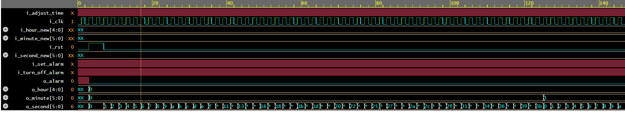
1st scenario re sults
Expected Result: The time (o_hour, o_minute, o_second) should increment every second.
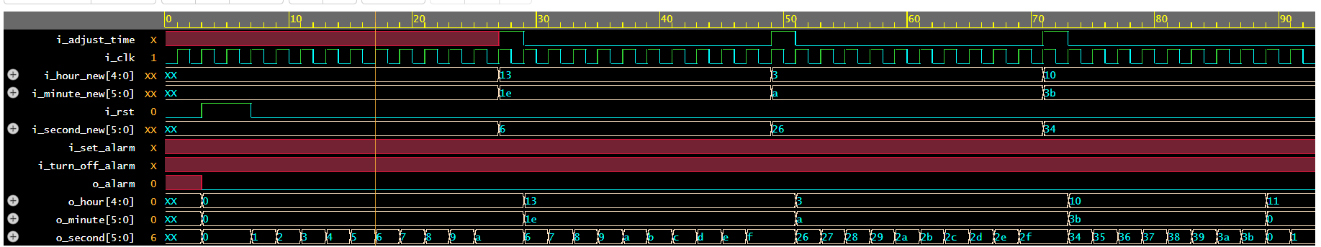
2nd scenario results

Expected Result: The time should be adjusted to the new values, and then the watch should continue counting from the adjusted time.
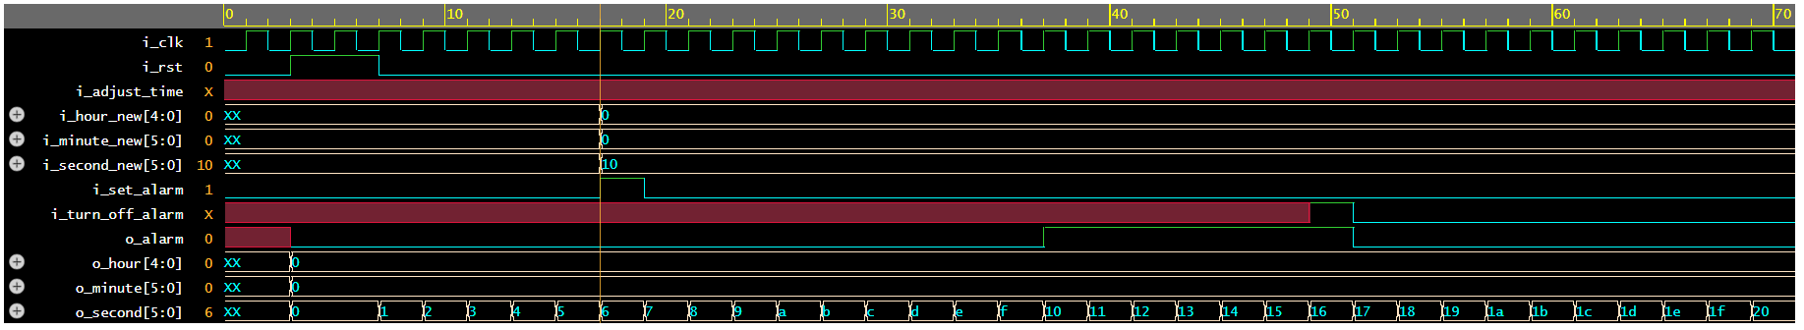
3rd scenario results

Expected Result: The alarm should trigger when the current time matches the set alarm time, and it should be turned off by the i_turn_off_alarm signal.

Conclusion:
The provided scenarios effectively test the core functionalities of the digital watch: normal mode operation, time adjustment, and the alarm feature.

